 | RESTRICTED |  | CONFIDENTIAL | X | INTERNAL |  | PUBLIC

Document Title : WI – User Manual – Portal HSE Escorter
Document Type : Work Instruction
Document Owner : IT & Automation
Document Code : xxx
Revision Number : 0.0
Last Revision Date : 18 Agustus 2026
 | Prepared By | Reviewed By | Approved By
Signature
Name | Muhamad Erzie Aldrian. N | Muhammad Yusron | Edwin Kharisman S.
Title | Staff, Automation | Engineer, Backend Developer | Sr Manager, IT & Automation

DOCUMENT HISTORY
Date | Rev. # | Department (Name) | Revision Explanation
18 Agt 2026 | 0.0 | IT & Automation | Initial release

Table of Contents
1 Objective 4
2 Scope 4
3 term & definition 4
4 INSTRUCTION 5
4.1 Login 5
4.2 Acknowledge Permit Activity 6
4.3 Approve Permit Activity 8

Objective
This document is intended to provide requester with detailed instructions on how to use the requester System Portal. This guide covers the login process, submitting acknowledge permit activity, and other features available to visitors within the portal.

Scope
The scope of this document is limited to the activities of users operating as Visitors. The processes discussed include:
- Login.
- Acknowledge Permit Activity.
- Approve Permit Activity.

term & definition
Term | Definition
System / Portal | The Visitor Management System web application or HSE Portal used to manage visitor registration and approval.
Visitor | An external party (vendor, contractor, or general visitor) who will be visiting the company’s premises.
Host | An employee or internal company representative who is the purpose of the Visitor’s visit.
Visit Request | A visit request that must be submitted by the Visitor prior to arrival.
Approval | The status indicating that the visit request has been approved by the Requester, Admin or the HSE department.

INSTRUCTION
- Login
- Open a web browser and go to the provided portal link (https://hse.dci-indonesia.com/), Use Forget password if you can’t remenber your password.
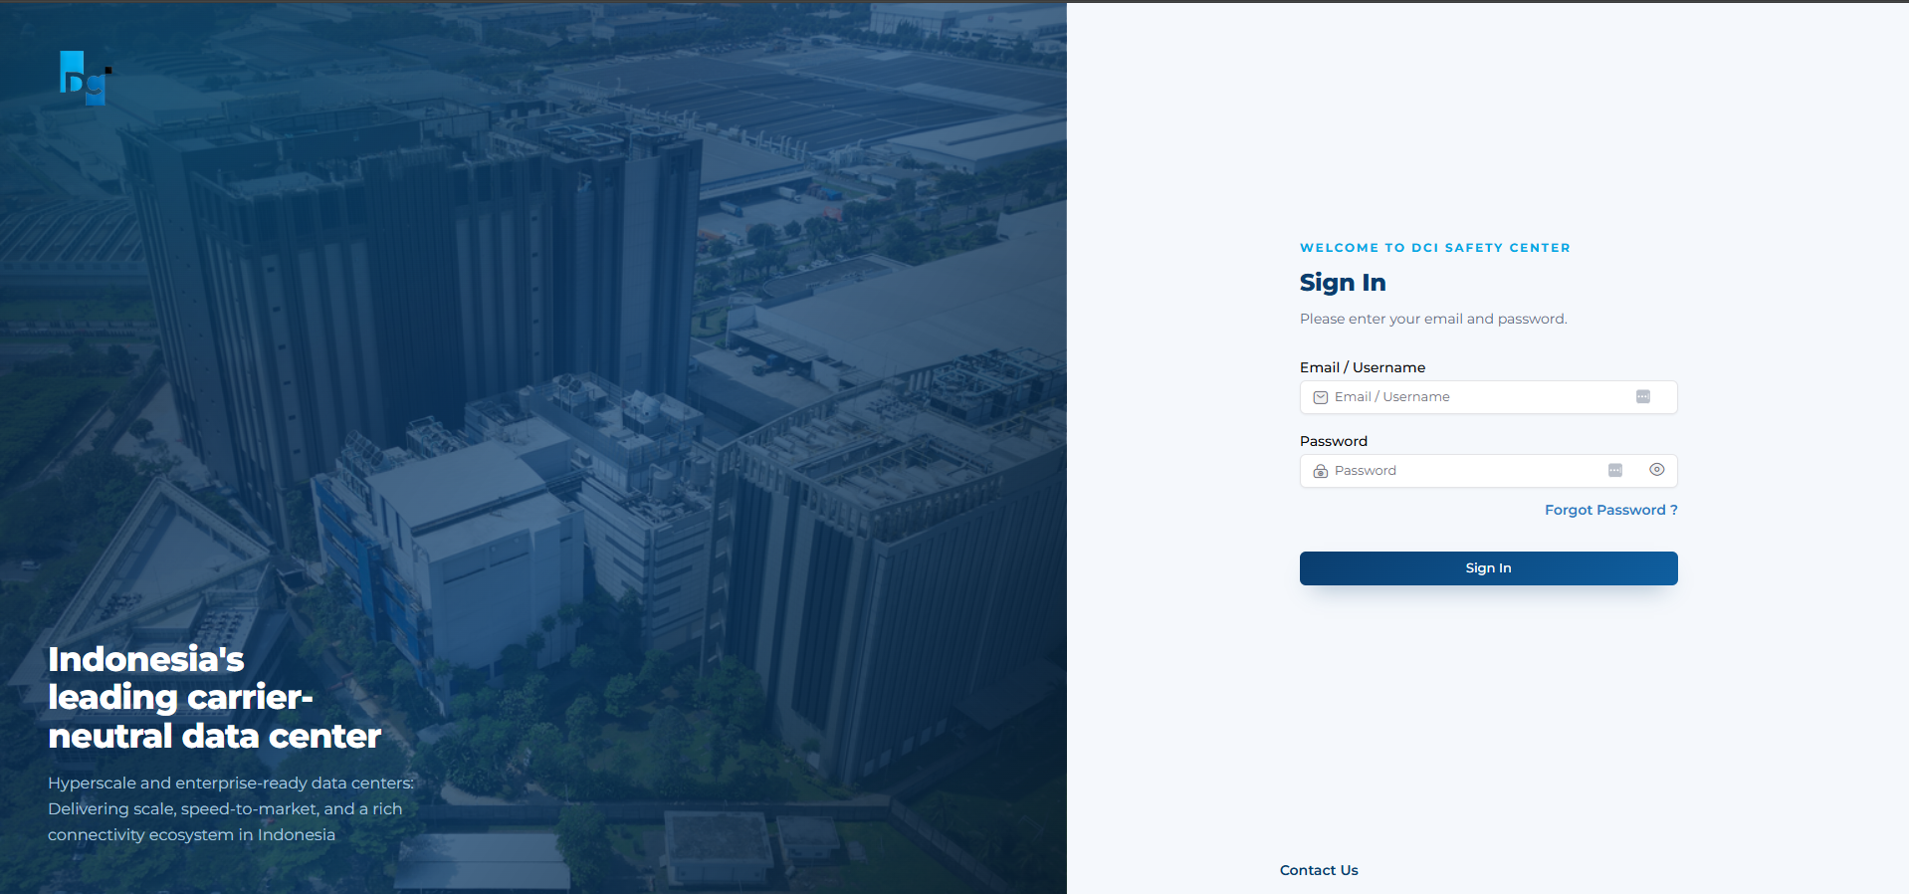
Image 1 Login Page Portal HSE
If your account email cannot be found, please contact the Admin for further information.

- After logging in, you will be automatically directed to the Permit Table page.
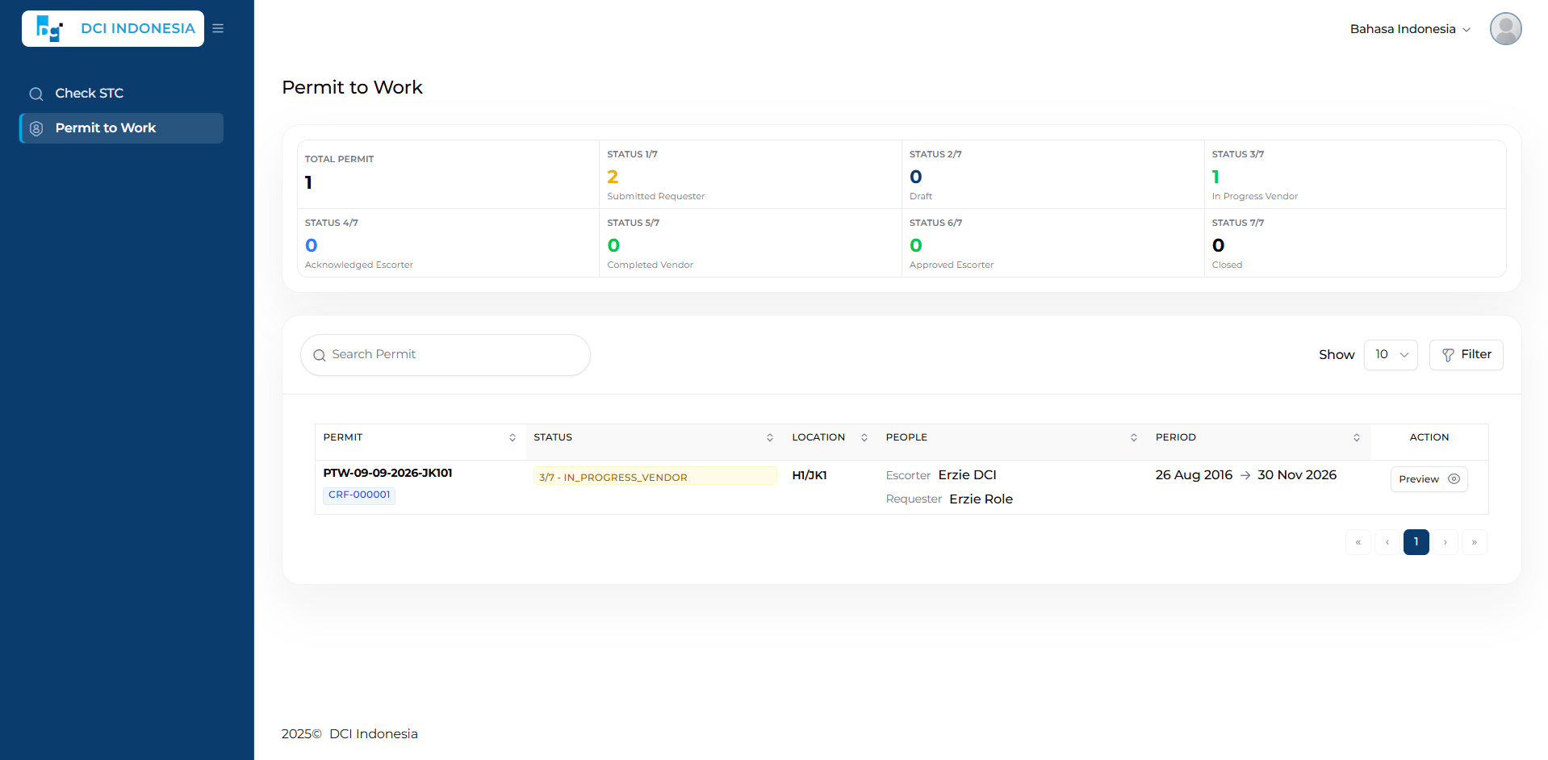
Image 2 Permit to Work Page
Di This page will display the permits for which you have been assigned as an Escorter. If you have never been assigned to any permit, the table will be empty.

- Acknowledge Permit Activity
- Make sure you receive an email notification regarding the Permit that requires your Acknowledgement, as shown below.
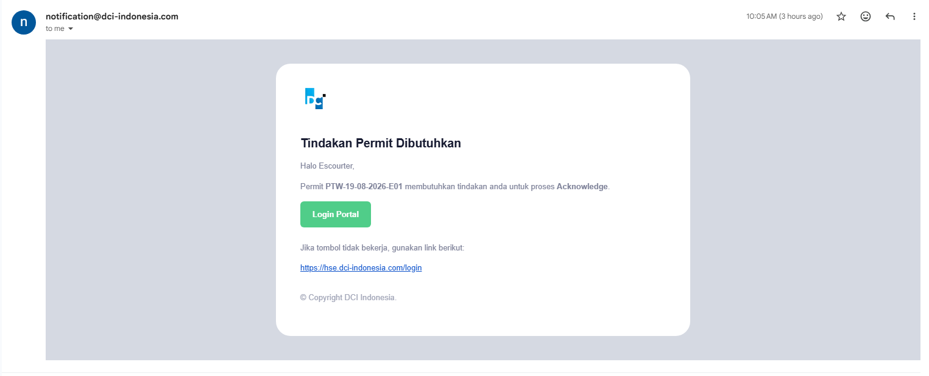
Image 3 Create New Permit
- After receiving the email, go to the Permit Table page, then select Action > Preview to view the details of the Permit Activity that requires acknowledgement.

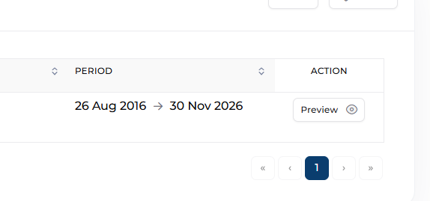
Image 4 Action Preview Activity Permit

- After entering the Preview page, you will be directed to the HSE Permit Activity Task page. Pick what Activity you want to Acknowledge, end then Escorter can go directly to the Update Daily Task section and click the Acknowledge button.
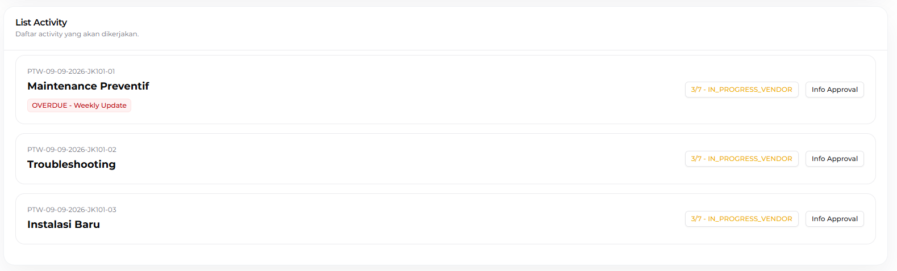
Image 5 Chose Activity
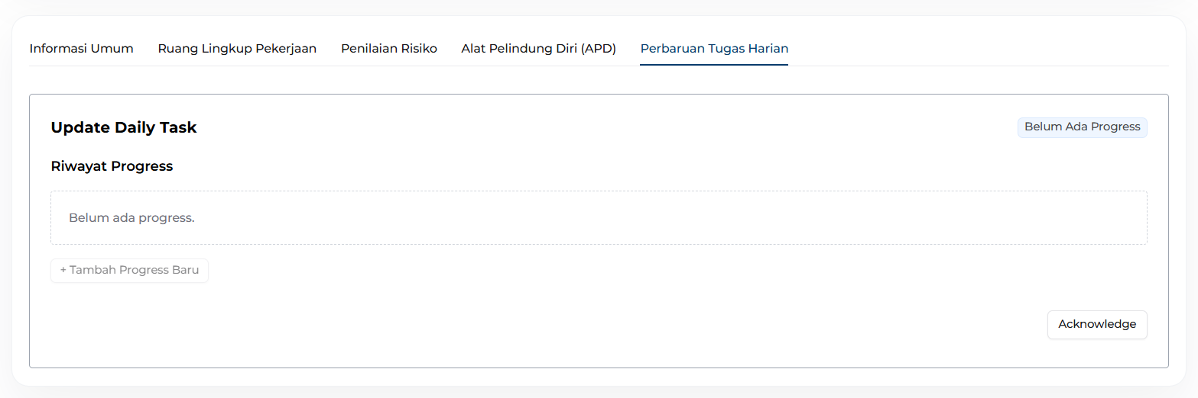
Image 6 Action Acknowledge for Activity Permit
If the Acknowledge button cannot be clicked, as shown below:
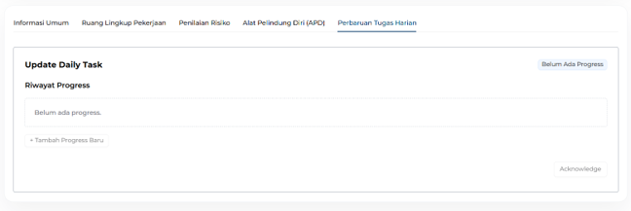
Image 7 Disabled Button Acknowledge
Please contact the HSE Team and Faculty Manager to request their approval. This may occur because the Risk Assessment for the activity is above the Medium level.
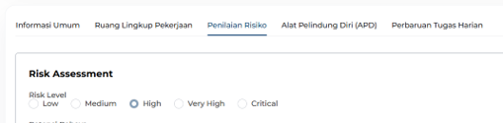
Image 8 Risk Assesment
The following shows the approval required for the activity.
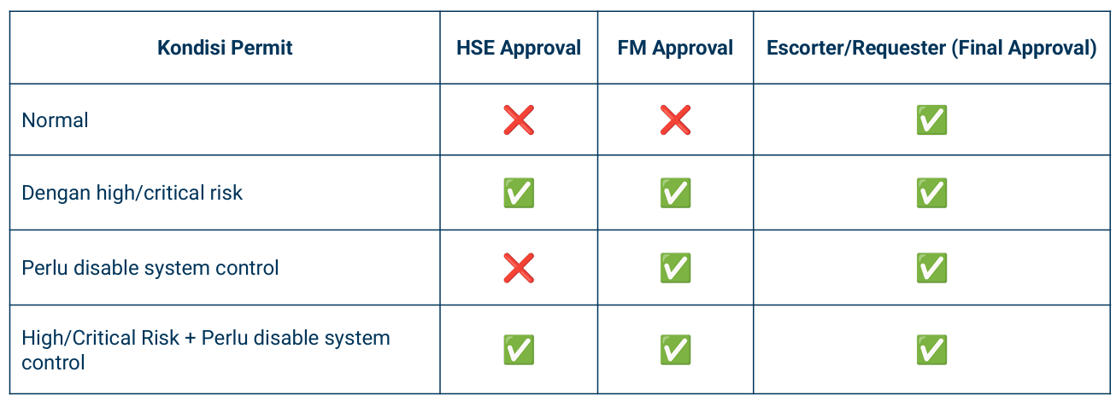
Image 9 Risk Assesment
- After that, go back to Activity. The Activity List status will be updated as shown below. Continue performing the Acknowledge action for other activities that require it.
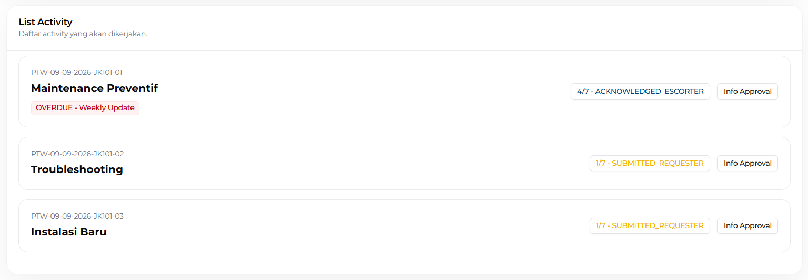
Image 10 List Activity change

following is the list of statuses available in the HSE Portal. If the status has reached 4/7 ACKNOWLEDGE ESCORTER, the Escourter cannot perform any further actions until escourter receive email for Approval Permit Activity.
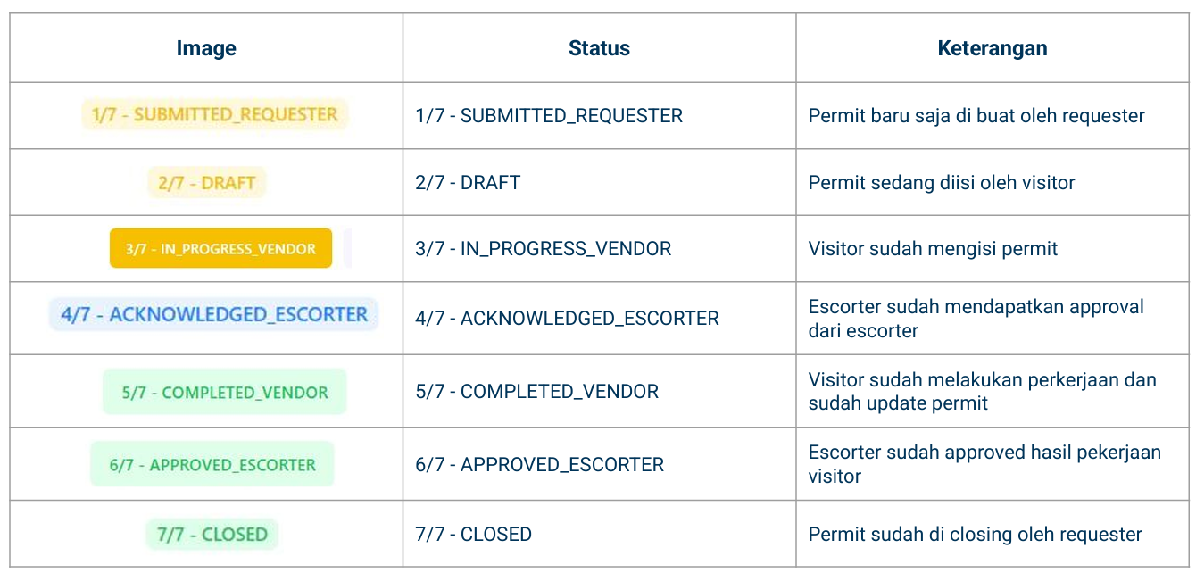
Image 11 Approval List for Activity
- Approve Permit Activity
- Make sure you receive an email notification regarding the Permit that requires your Approval, as shown below.
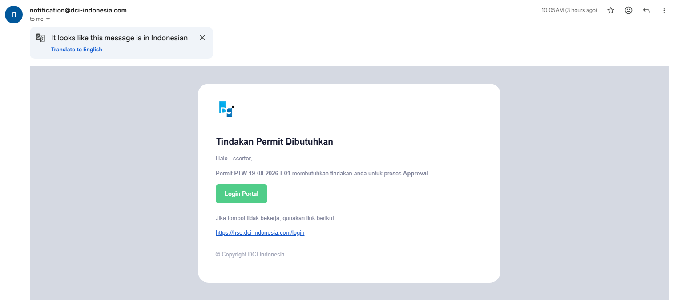
Image 12 Email Approval for Escorter
- After receiving the email, go to the Permit Table page, then select Action > Preview to view the details of the Permit Activity that requires approval.

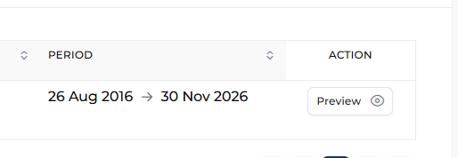
Image 13 Action Preview Activity Permit

- After entering the Preview page, you will be directed to the HSE Permit Activity Task page. From here, the Escorter can go directly to the Update Daily Task section and click the Approve button. Perform the same steps for other activities that require approval.

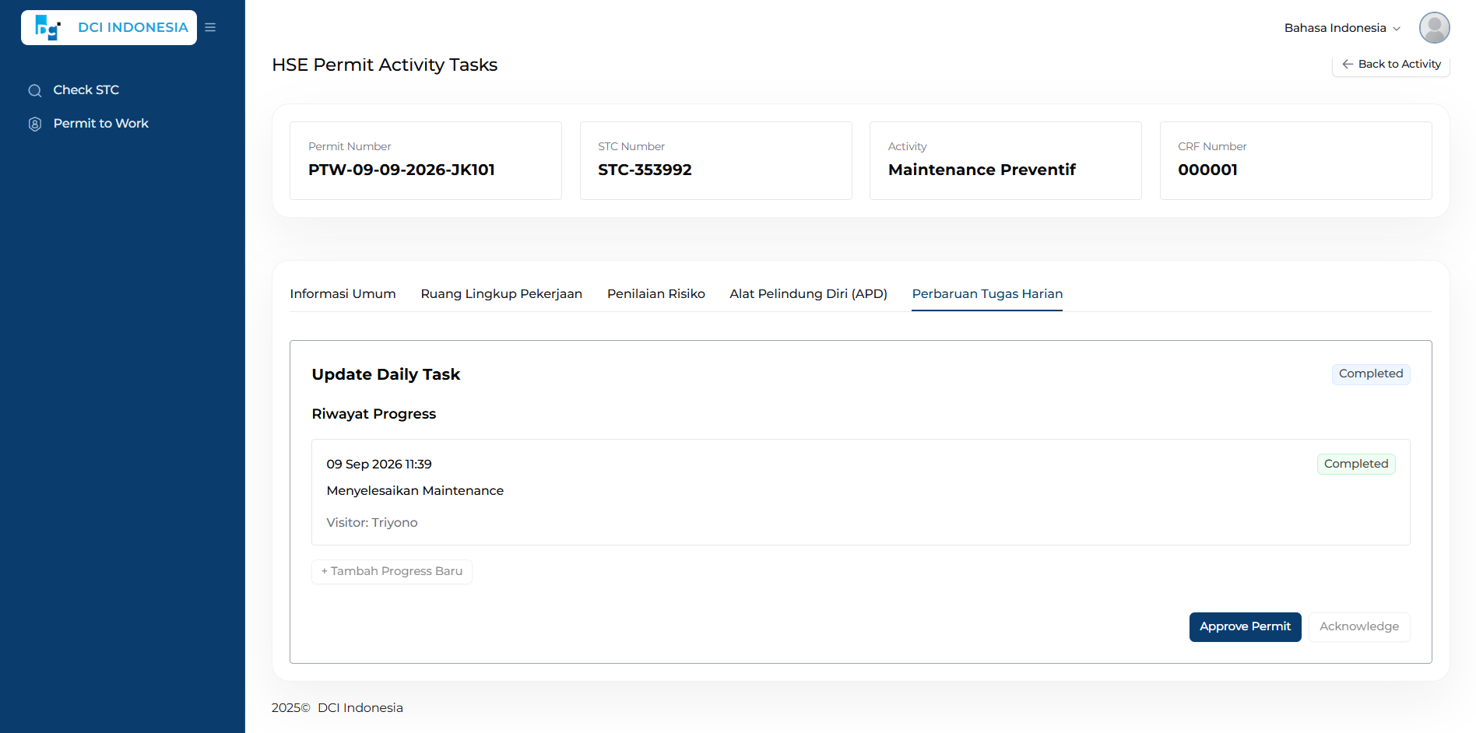
Image 14 Action Approve for Activity Permit
- You can return to the Activity List page. All activities will be displayed with the status 6/7 APPROVED ESCORTER. Setelah ini Escorter tidak dapat melakukan apapun dan menunggu Close Permit dari Requestor.
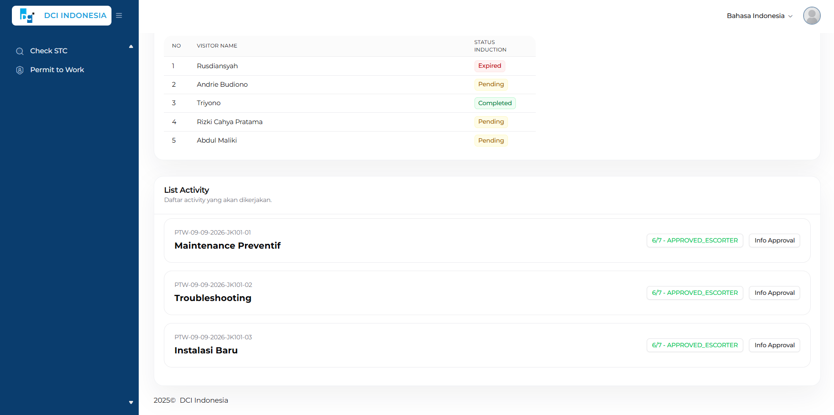
Image 15 Activity List Status after Escorter Approve

